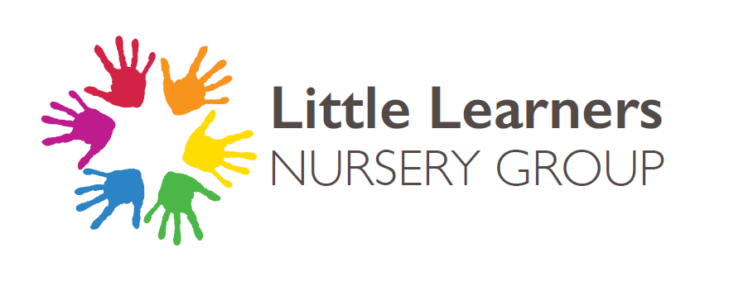

More Able Children

Created: June 2026

To be reviewed: June 2028

Company Reg.No. 08812259 Registered Office: Brooke Road, Walthamstow, London E17 9HJ Charity Reg. No:1157645

Aims
- To provide teaching which makes learning challenging and enjoyable and enables children to achieve their potential
- To identify pupils who are achieving or have the potential to achieve in advance of the average for their age
- To ensure that all children are offered differentiated learning opportunities, appropriate to their abilities
- To provide for the learning needs of those children who may be identified as more able by offering a curriculum that extends and challenges them
- To foster independent learning, creativity and thinking skills
Definition
We have chosen to use the term “more able” and to adopt the DCSF definition: thus pupils identified on our “More Able” register will constitute 5 – 10% of the cohort and will be achieving in advance of the average for their year group in one or more areas or have the potential to do so. They may also be pupils who have a particular talent.
More Able Children (MAC)
Pupils may:
- Be good “all rounders”
- Be talented (show ability in the arts, music, sport, gymnastics)
- Have academic ability (in one or more subjects of the national curriculum)
Provision
- To provide high-quality learning challenges, experiences and enrichment opportunities
- To provide a range of differentiated tasks and activities, including “Challenges”
- To ensure the most able make appropriate progress

Equality Statement
Pupils with EAL and those with SEND will be given equal access to MAC identification.
Partnership with Parents
Parents and carers will be kept informed of their children’s progress through termly open evenings and will be offered advice on how best to support their children outside school.
The views of parents and carers will be sought and, where appropriate, noted at open evenings, in order to gain an all-round picture of the child’s interests and abilities.
Using Famly, parents and nursery staff can share learning and achievement observation.

